Riverside Unified School District
Online Parent Portal
Account Setup Tutorial

The following are step by step procedures to create an online parent account to access your child’s grades, attendance, schedules, assignments, teacher information and more.

Parents must have the following 3 information items to create an account and associate that account with their student or students.

1. Child’s student permanent ID number
2. School verification code
3. Parents must know the primary telephone number on record with their child’s school

To create your account.

- Open your web browser and go to https://aeriesweb.rusd.k12.ca.us/parent and click the “Create New Account” link in the bottom left corner of the screen. Note:

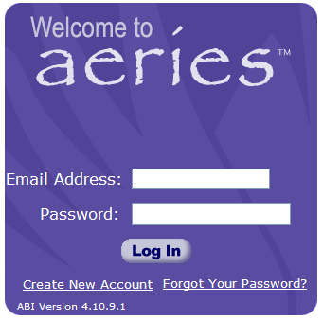

- The first step of the sign up process brings up the account type option. Choose the “Parent” account
Option as shown below and click the Next button.

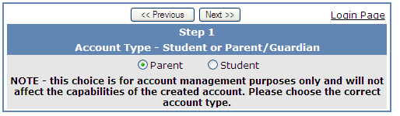
- In Step 2, you will create your account using your personal email address. Enter your email address in the Email Address and Verify Email Address fields. For illustration we have used a fictitious email address. Enter a password in the Choose Password field and retype the same password in the Retype Password field. Choose something you can easily remember but is not easy for someone else to guess. Then click the Next button.

NOTE: Passwords can be changed via a link on the Parent Portal home page after the registration process is complete.

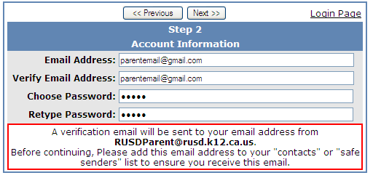

- In Step 3 you must confirm the email address you entered on the previous screen. When you see the screen below an email has been sent to the email address that you specified on the previous screen. The registration process has been halted until you open your email and confirm your email address.

IMPORTANT: YOU MUST OPEN, READ AND FOLLOW THE INSTRUCTIONS IN THE EMAIL YOU RECEIVE IN ORDER TO CONTINUE CREATING YOUR PARENT PORTAL ACCOUNT.

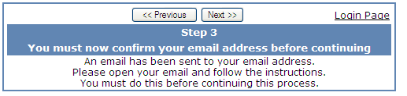

- You may now close this window and open your email program. Do not click on the Previous or Next button.

- Once in your email program open the email from RUSDParent@rusd.k12.ca.us (do not reply to this non-monitored email account). You will see an email similar to the one below. Follow the directions in the email and click on the Confirm Current Email Address link. If you cannot click on the link follow the remaining directions in the email.

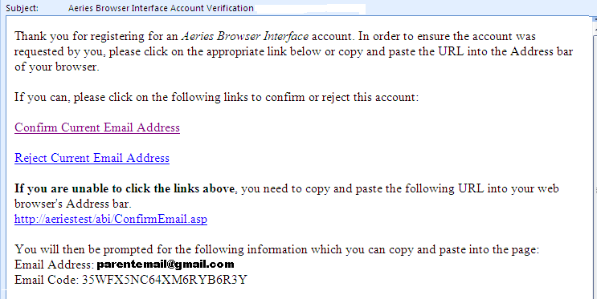

- A window will appear once you confirm your email address like the one illustrated below. To continue the registration process click on the Click Here link in the message.

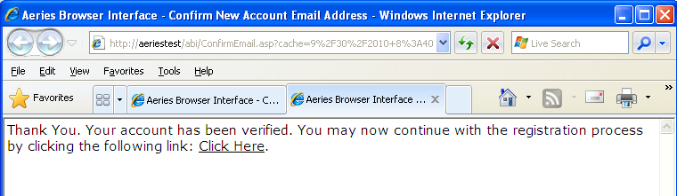

- After clicking on the link the registration process will continue with Step 4. The “Student Verification” form will be displayed. This is the form where you enter the 3 information items that associate you with your student. If you do not have this information, contact your child’s school office. The registration process will need to be restarted if you exit out of the sign up process.
  - Enter the information in each box and when done click the Next button. Note that the telephone number can be entered with dashes and parenthesis example: (951)555-8787 or without example: 9515558787. The program will recognize the telephone number as long as the numbers are correct.

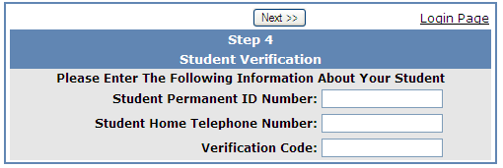

- After clicking the Next button on the previous screen you will proceed to Step 5 “Emergency Contact” Verification. Click the button next to your name or click “None of the above” if you do not appear in the list. Click the Next button to complete the account creation process.

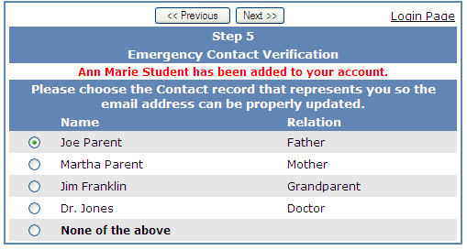

- You will be presented with the final Step 6 screen. By clicking on the Click Here link you will be able to log into the system immediately. You can log in anytime after you have created your account by opening your Web browser and going to https://aeriesweb.rusd.k12.ca.us/parent

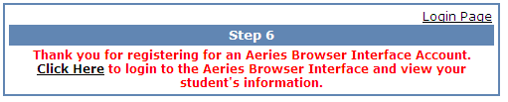

How to Add Additional Students to an Account

- Log into the ABI Parent Portal and you will see on the home page, in the header bar at
the top of the screen, a drop down menu labeled Current Student:

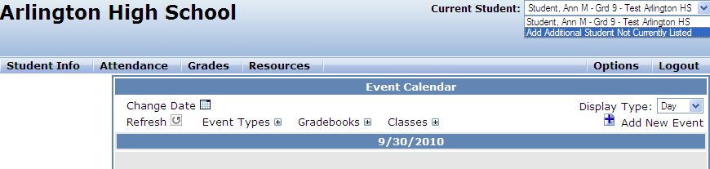

- Click the dropdown list and choose: “Add Additional Student Not Currently Listed”

- You will be taken to a page that will prompt you for the new student’s ID number, telephone
number and verification code. This is similar to Step 4 when you created your account and associated your first student with your login. Enter the information for this student and click the Next button.

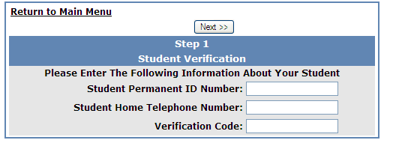

- Once the system confirms the information is correct, a confirmation will be displayed. This screen resembles the confirmation screen in Step 5 when you created your account. Click the button of the contact that describes you or “None of the above” and click the Next button.

- When finished you will see multiple students in the Current Student dropdown list and can easily switch
between them by clicking on the one you wish to view.

Forgot Your Password?

- Open your web browser and go to https://aeriesweb.rusd.k12.ca.us/parent and click the “Forgot Your Password?” link in the bottom right corner of the screen.

- Once the link is clicked, you will be taken to a page where you can enter your email address.
After you enter your email address, click the Go button and an email will be sent to you.

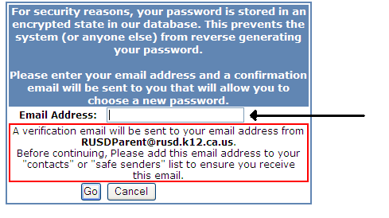

- Open the email and click on the “Click Here” link in the email. If you cannot click on “Click Here” then manually go to the URL specified and enter the required information.

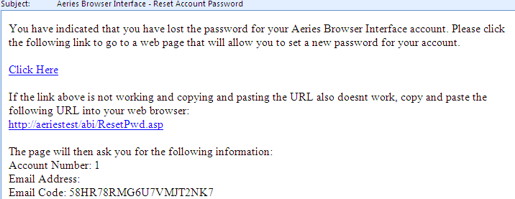

- Once you click the link, the system confirms that the process has been followed correctly and
allows you to enter a new password for your account.

