Chapter 17 PPT Diagrams

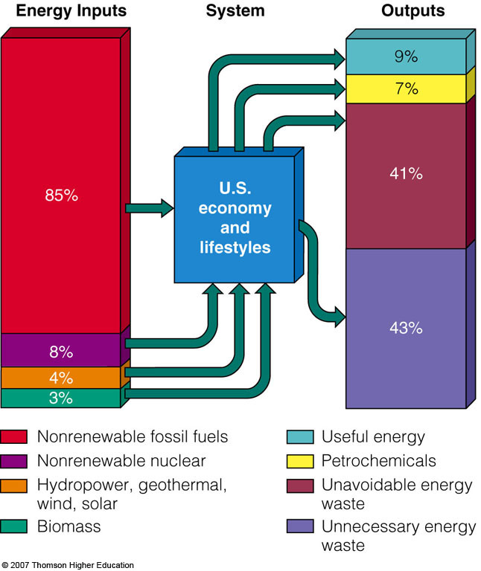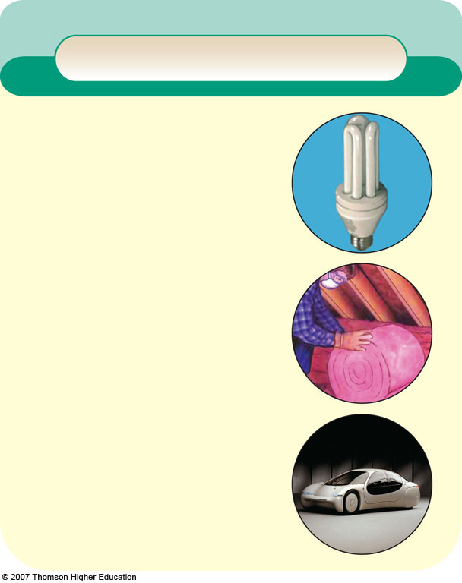

Solutions
Reducing Energy Waste
Prolongs fossil fuel supplies
Reduces oil imports
Very high net energy
Low cost
Reduces pollution and environmental degradation
Buys time to phase in renewable energy
Less need for military protection of Middle East oil resources
Creates local jobs

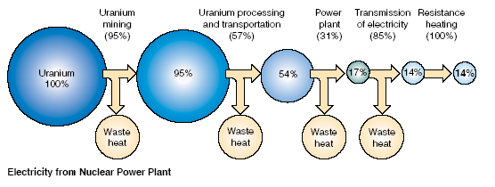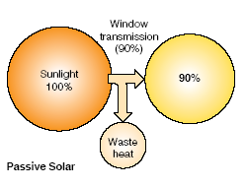
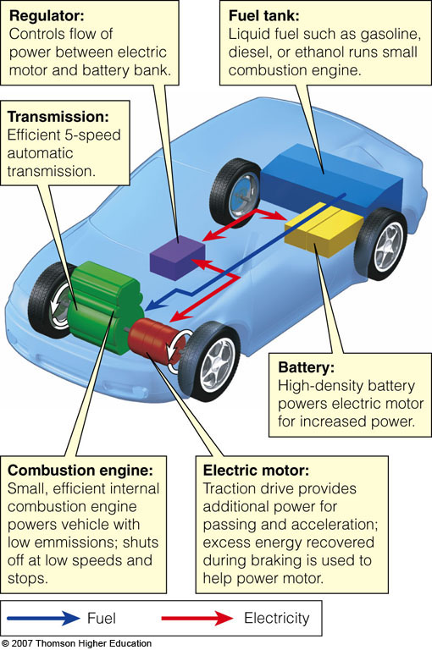
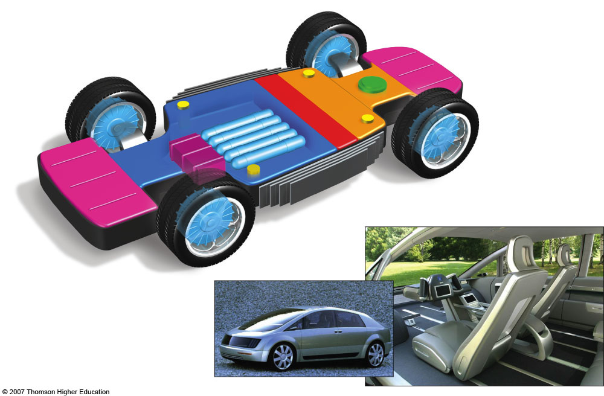

Body attachments
Mechanical locks that secure the body to the chassis
Air system management
Universal docking connection
Connects the chassis with the drive-by-wire system in the body
Fuel-cell stack
Converts hydrogen fuel into electricity
Rear crush zone
Absorbs crash energy
Drive-by-wire system controls
Cabin heating unit
Side-mounted radiators
Release heat generated by the fuel cell, vehicle electronics, and wheel motors
Hydrogen fuel tanks
Front crush zone
Absorbs crash energy
Electric wheel motors
Provide four-wheel drive; have built-in brakes
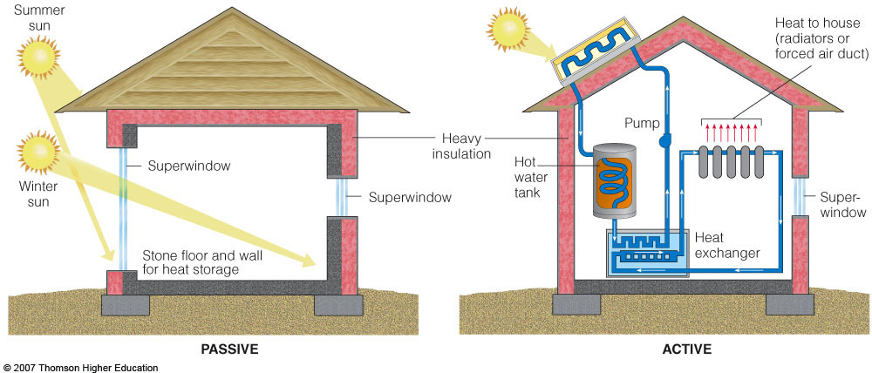
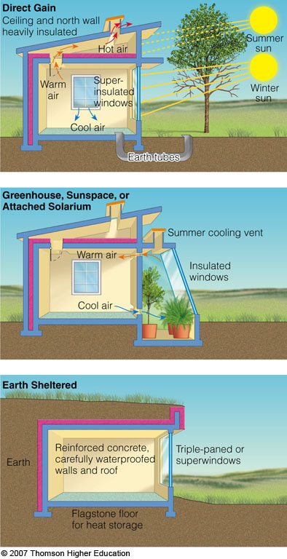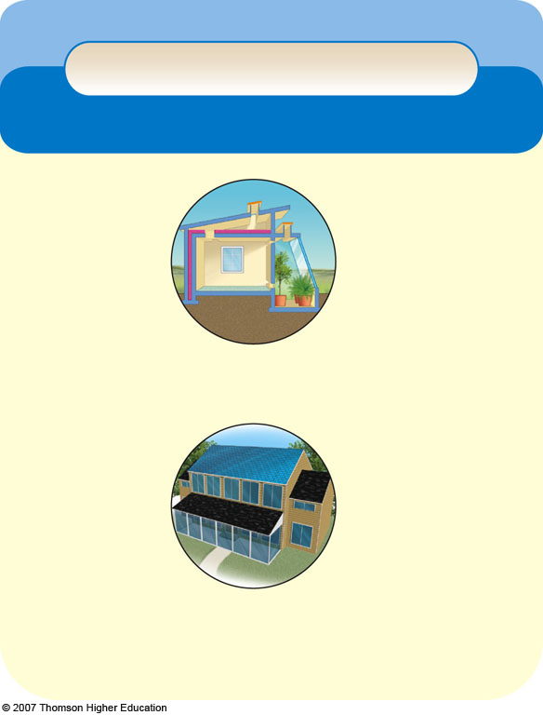

Trade-Offs
Passive or Active Solar Heating
Advantages
Disadvantages
Energy is free
Need access to sun 60% of time
Net energy is moderate (active) to high (passive)
Sun blocked by other structures
Need heat storage system
Quick installation
No CO₂ emissions
Very low air and water pollution
High cost (active)
Very low land disturbance (built into roof or window)
Active system needs maintenance and repair
Moderate cost (passive)
Active collectors unattractive
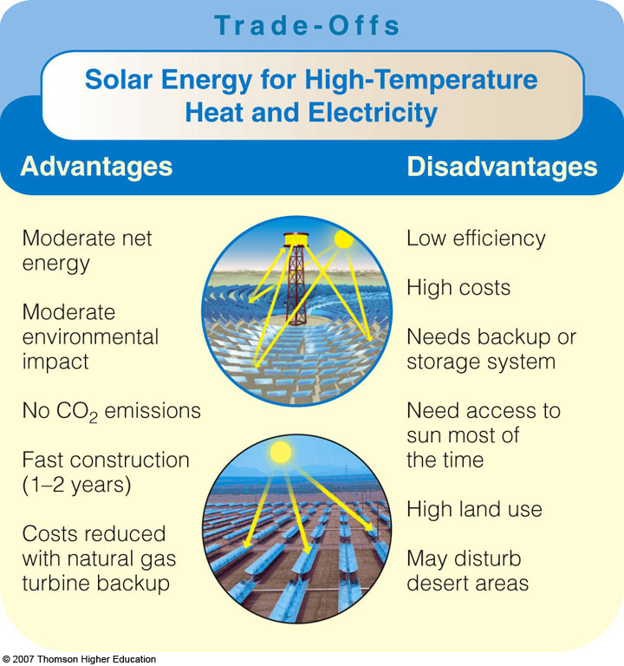
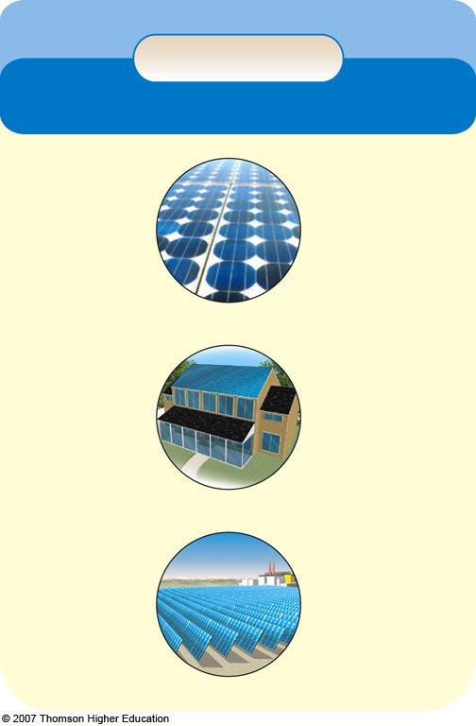

Trade-Offs
Solar Cells
Advantages
Disadvantages
Fairly high net energy
Need access to sun
Work on cloudy days
Low efficiency
Quick installation
Need electricity storage system or backup
Easily expanded or moved
No CO₂ emissions
High land use (solar-cell power plants) could disrupt desert areas
Low environmental impact
Last 20–40 years
Low land use (if on roof or built into walls or windows)
High costs (but should be competitive in 5–15 years)
Reduces dependence on fossil fuels
DC current must be converted to AC
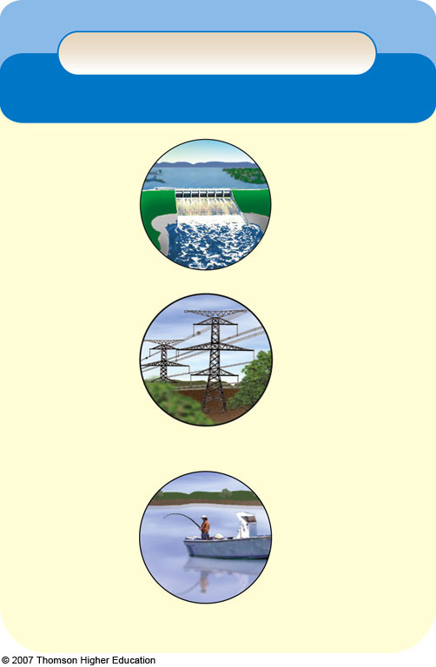

Trade-Offs
Large-Scale Hydropower
Advantages
Disadvantages
Moderate to high net energy
High construction costs
Large untapped potential
High environmental impact from flooding land to form a reservoir
High efficiency (80%)
High CO₂ emissions from biomass decay in shallow tropical reservoirs
Low-cost electricity
Long life span
No CO₂ emissions during operation in temperate areas
Floods natural areas behind dam
May provide flood control below dam
Converts land habitat to lake habitat
Danger of collapse
Provides water for year-round irrigation of cropland
Uproots people
Decreases fish harvest below dam
Reservoir is useful for fishing and recreation
Decreases flow of natural fertilizer (silt) to land below dam
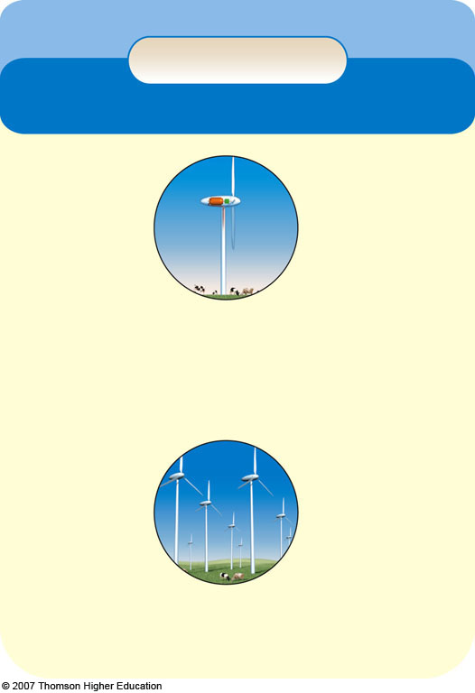

Trade-Offs
Wind Power
Advantages
Disadvantages
Moderate to high net energy
Steady winds needed
Backup systems needed when winds are low
High efficiency
Moderate capital cost
Low electricity cost (and falling)
High land use for wind farm
Very low environmental impact
No CO₂ emissions
Visual pollution
Quick construction
Noise when located near populated areas
Easily expanded
Can be located at sea
Land below turbines can be used to grow crops or graze livestock
May interfere in flights of migratory birds and kill birds of prey
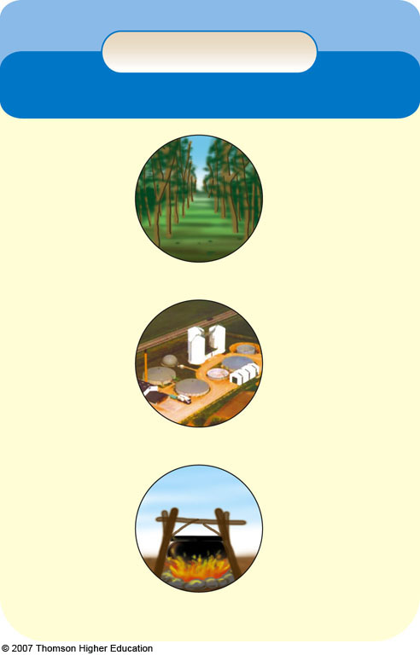

Trade-Offs
Solid Biomass
Advantages
Disadvantages
Large potential supply in some areas
Nonrenewable if harvested unsustainably
Moderate costs
Moderate to high environmental impact
No net CO₂ increase if harvested and burned sustainably
CO₂ emissions if harvested and burned unsustainably
Low photosynthetic efficiency
Plantation can be located on semiarid land not needed for crops
Soil erosion, water pollution, and loss of wildlife habitat
Plantation can help restore degraded lands
Plantations could compete with cropland
Often burned in inefficient and polluting open fires and stoves
Can make use of agricultural, timber, and urban wastes
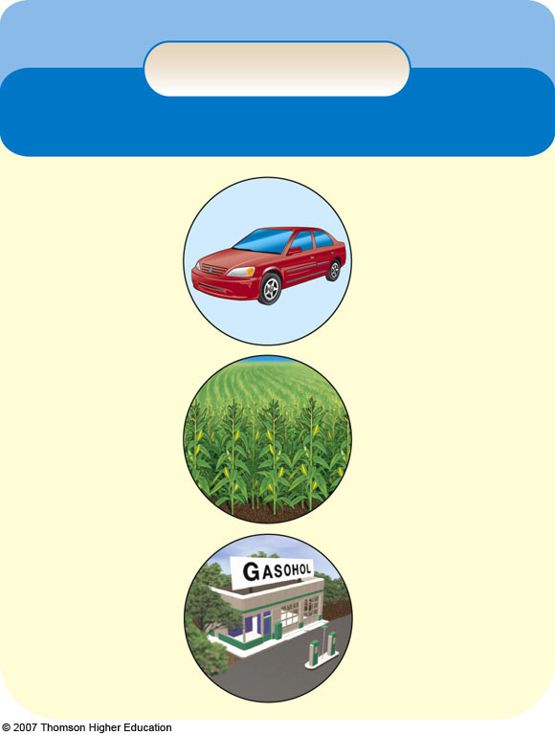

Trade-Offs
Ethanol Fuel
Advantages
Disadvantages
High octane
Large fuel tank needed
Some reduction in CO₂ emissions
Lower driving range
Low net energy (corn)
High net energy (bagasse and switchgrass)
Much higher cost
Corn supply limited
Reduced CO emissions
May compete with growing food on cropland
Can be sold as gasohol
Higher NO emissions
Corrosive
Potentially renewable
Hard to start in cold weather
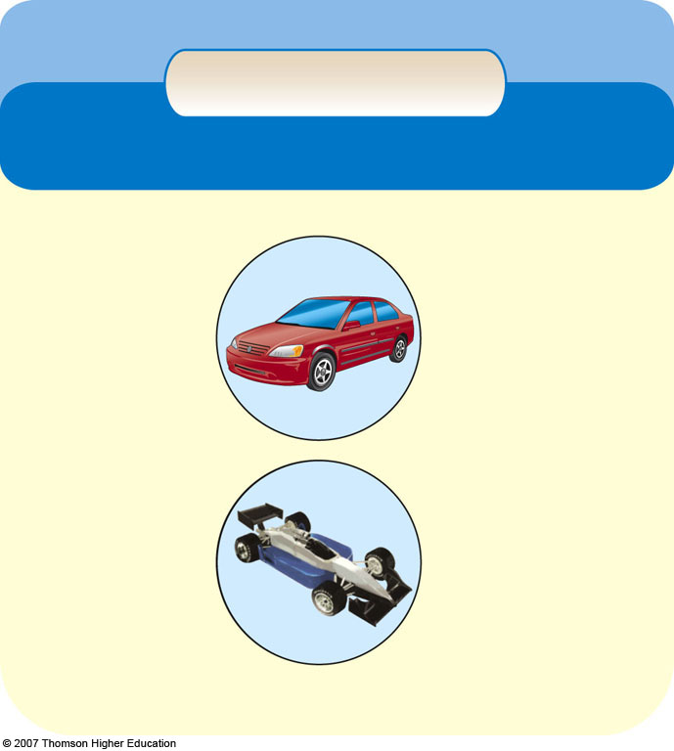

Trade-Offs
Methanol Fuel
Advantages
Disadvantages
High octane
Large fuel tank needed
Some reduction in CO₂ emissions
Half the driving range
Lower total air pollution (30–40%)
Corrodes metal, rubber, plastic
Can be made from natural gas, agricultural
wastes, sewage sludge, garbage, and CO₂
High CO₂ emissions if made from coal
Expensive to produce
Can be used to produce H₂ for fuel cells
Hard to start in cold weather

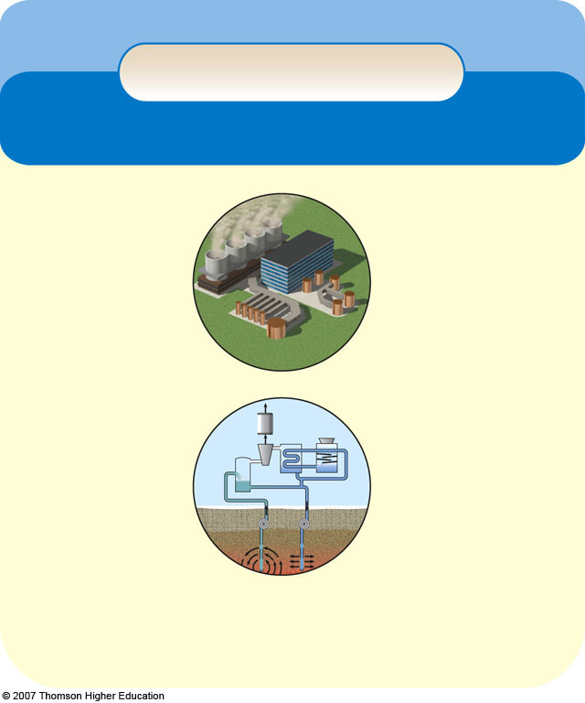

Trade-Offs
Geothermal Energy
Advantages
Disadvantages
Very high efficiency
Scarcity of suitable sites
Moderate net energy at accessible sites
Depleted if used
too rapidly
Lower CO₂ emissions than fossil fuels
Moderate to high local air pollution
Low cost at favorable sites
CO₂ emissions
Noise and odor (H₂S)
Low land use
Low land disturbance
Cost too high
except at the most concentrated and accessible sources
Moderate environmental impact
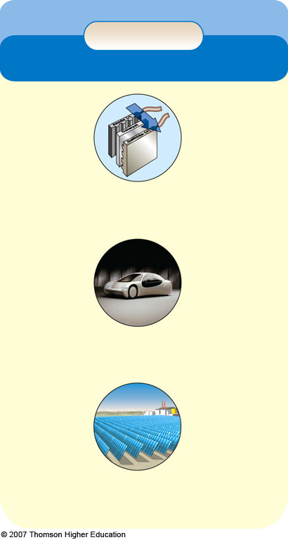

Trade-Offs
Hydrogen
Advantages
Disadvantages
Not found in nature
Energy is needed to produce fuel
Negative net energy
Renewable if from renewable resources
CO₂ emissions if produced from carbon-containing compounds
No CO₂ emissions if produced
from water
Nonrenewable if generated by fossil fuels or nuclear power
Good substitute for oil
Competitive price if environmental & social costs are included in cost comparisons
High costs (but may eventually come down)
Will take 25 to 50 years to phase in
Easier to store than electricity
Short driving range for current fuel-cell cars
Safer than gasoline and natural gas
No fuel distribution system in place
Nontoxic
High efficiency (45–65%) in fuel cells
Excessive H₂ leaks may deplete ozone in the atmosphere
Can be produced from plentiful water
Low environmental impact

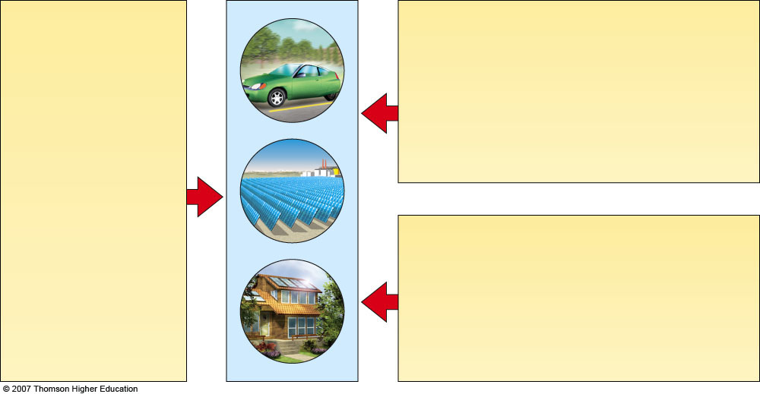

What Can You Do?
Energy Use and Waste
• Get an energy audit at your house or office.
• Drive a car that gets at least 15 kilometers per liter (35 miles per gallon) and join a carpool.
• Use mass transit, walking, and bicycling.
• Superinsulate your house and plug all air leaks.
• Turn off lights, TV sets, computers, and other electronic equipment when they are not in use.
• Wash laundry in warm or cold water.
• Use passive solar heating.
• For cooling, open windows and use ceiling fans or whole-house attic or window fans.
• Turn thermostats down in winter, up in summer.
• Buy the most energy-efficient homes, lights, cars, and appliances available.
• Turn down the thermostat on water heaters to 43–49°C (110–120°F) and insulate hot water heaters and pipes.

Fig. 17-36, p. 415
More Renewable Energy

Increase renewable energy to 20% by
2020 and 50% by 2050

Provide large subsidies and tax
credits for renewable energy

Use full-cost accounting and life-cycle
cost for comparing all energy
alternatives

Encourage government purchase of
renewable energy devices

Greatly increase renewable energy
R&D
Reduce Pollution and Health Risk

Cut coal use 50% by 2020

Phase out coal subsidies

Levy taxes on coal and oil use

Phase out nuclear power or put it on
hold until 2020

Phase out nuclear power subsidies
Improve Energy
Efficiency

Increase
fuel-efficiency
standards for
vehicles, buildings,
and appliances

Mandate govern-
ment purchases
of efficient vehicles
and other devices

Provide large tax
credits for buying
efficient cars, houses,
and appliances

Offer large tax
credits for invest-
ments in energy
efficiency

Reward utilities for
reducing demand for
electricity

Encourage indepen-
dent power producers

Greatly increase energy
efficiency research and
development

