Lesson 1 Student Activity Sheets: What explains why the population of buffaloes in the Serengeti changes so much?

BACKGROUND KNOWLEDGE:

1. What do you know about the wildlife in Africa?

2. What types of animals are there?

3. What does the landscape look like?

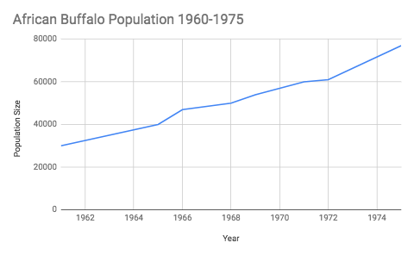

PROCEDURE:
4. Analyze the graph to the right. What patterns do you notice in the graph? Record these in the space below.

INITIAL MODELS:
5. What ideas do you have to explain why the population of buffalo increased so rapidly? Draw an initial model in the space below.

6. What general information about the Serengeti do we need to research to further investigate the causes for the changes in the African buffalo population?

OBSERVATIONAL DATA:
7. Watch a video clip to give you some visual background information about the Serengeti. Make a record below of at least 3 observations (what you see) from the video.

Observations
INVESTIGATION 1

PROCEDURE:
View the Serengeti National Park on Google Maps and the camera trap data below to gather more information about the location of the Serengeti and the animals that live there. Then, use these data sources, along with your observations and takeaways from the video, to answer the Making Sense Questions about the Serengeti.

DATA:
Fig 1 (Below) Table of photo capture events by species. Data taken between June 2010 and May 2013 produced 1.2 million image sets (each image set contains 1–3 photographs taken in a single burst of ~1 s). Data taken from: https://www.nature.com/articles/sdata201526
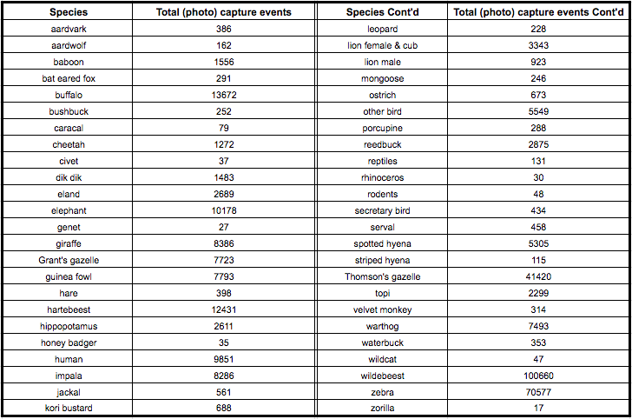

MAKING SENSE:
8. Where is the Serengeti located in the continent of Africa?

9. What predictions can we make about the climate of the Serengeti based on its location on the map? Be specific.

10. What do you notice about the border of the Serengeti? Do you think the borders are closed off by fences? Explain your answer with observations from the map.

11. According to the photo capture data, which 6 animals are most represented in the data? Be sure to list the name of the species and the number of photo captures.

12. What are at least 2 things that all these animals have in common? (Besides the fact that they live in the Serengeti).

13. Compare and contrast the number of photo captures for predators like cheetahs and lions, to the number of photo captures of the animals you listed in question 14. What do you notice?

14. Considering your observations from the video and the photo capture data, what conclusions can we draw about the biodiversity of the Serengeti? Be sure to use at least 1 data point to justify your response.

INVESTIGATION 2

PROCEDURE:
15. Read the passage titled, “The Serengeti Plain.” In the margin next to each paragraph, write a brief bullet point that summarizes the main idea of that chunk. There are 5 paragraphs, so you should have 5 notes once you are finished.

The Serengeti Plain:
The Serengeti has more than 2 million herbivores and thousands of predators. Blue Wildebeests, gazelles, zebras and buffalos are the animals most commonly found in the region. A significant portion of the Serengeti Plain is protected and preserved from the ravages of modern society in the Serengeti National Park. This park, which extends for roughly 12,950 square kilometers, contains a diverse selection of habitats and wildlife. For the sake of comparison, the Serengeti National Park is about 5,000 square miles and approximately the size of Northern Ireland.
The Serengeti National Park is bordered by Lake Victoria in the west, Lake Eyasi in the south, and the Great Rift Valley to the east. The landscape of the Serengeti Plain is extremely varied, ranging from to hilly woodlands, to savannas and grasslands. Although savannas and grasslands are similar, compared to grasslands, savannas have some shrubs and isolated tree cover. The geographic diversity of the region is due to the extreme weather conditions in the area, particularly the potent combination of heat and wind. Many environmental scientists claim that the diverse habitats in the region originated from a series of volcanoes, whose activity shaped the basic geographic features of the plain and added mountains and craters to the landscape.
In the southern portions of the plain, broad expanses of open grassland play host to herds of zebras and wildebeest, images which have become closely associated with the Serengeti. To the north of the grasslands lie the savanna, home to gazelles and ostriches. This zone of the plain is also famous for granite boulder outcroppings called kopjes, that interrupt the plains and play host to separate ecosystems. To the north of the savanna lies a wooded, hilly region that combines many of grassland features of the savanna, with more difficult terrain. This area of the plain is host to herds of elephants, evidence of which can be seen in the damaged trees scattered throughout the area.
The climate of the Serengeti Plain is predominantly warm and dry, with the rainy season falling between March and May. During times where the rainfall is steady, the environment is rich and lush with plant life. Soon after the rains stop, however, the green landscape begins to dry out and prepare again for the rains. During this time, rains cease the streams run dry and the lush green grass turns brown. As with all grasslands, wildfire is another significant driver of environmental change.
One of the most eye catching events in the Serengeti Plain is the biannual migration of zebras and wildebeest from the grasslands of the south to the northern reaches of the plain. This migration, which is the longest overland migration in the world, first takes place in May, when the grasslands of the south begin to dry up. Unable to survive on the dry plain, the wildebeest lead the charge toward the north. The zebras then join into the mass migration, careful to maintain their family groupings in the the movement. Once November comes to the Serengeti Plain, the wildebeest and the zebras begin their migration back to the grasslands of the south. When leaving the northern plains, lions and cheetahs often follow the herd, posing a significant threat to animals who fall too far behind. It’s important to note that not all animals in the Serengeti migrate. In fact, some animals- like buffalo- usually do not migrate to stay near consistent water sources.
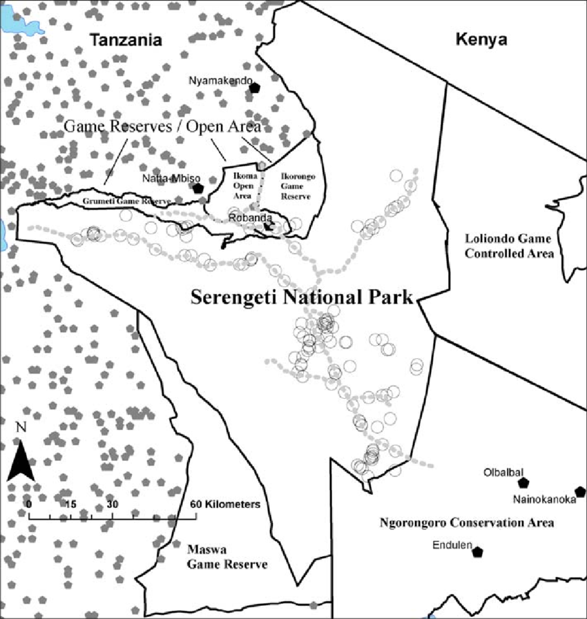
MAKING SENSE:
16. Use the information from the reading to label the map (to the right) with arrows to symbolize the general migration pattern for the wildebeest and zebra.

17. In ecology, a landscape refers to a group of interacting ecosystems. In your own words, describe the landscape of the Serengeti.

CONCLUSION:
On your own, use what we figured out today during our class discussion, the map, data table and reading to answer the question below.

18. What can we conclude about the biodiversity and concentration of different species in the Serengeti? Cite at least 2 data points to justify your conclusions.
______________________________________________________________________________________________________________________________________________________________________________________________________________________________________________________________________________________________________________________________________________________________________________________________________________________________________________________________________________________________________________________________________________________________________________________________________________________________________________________________________________

NEXT STEPS:
19. What should we investigate in our next lesson?

